Dis-Eur-Paleo-Spain-Cantabria- 36,000 BP

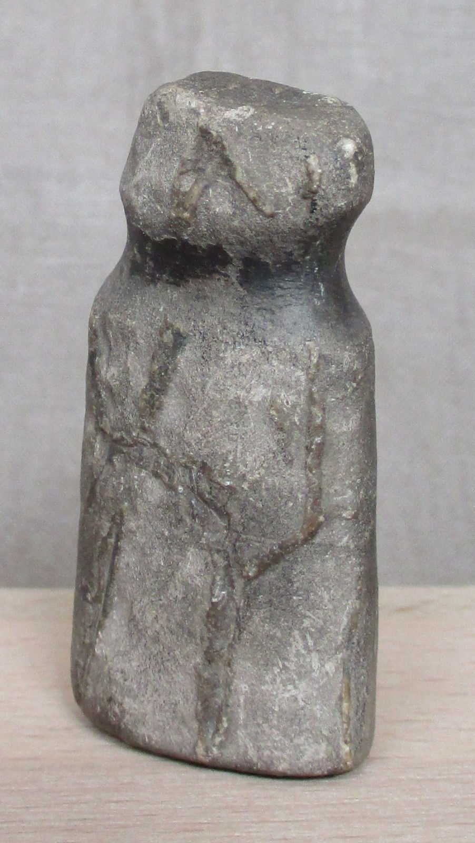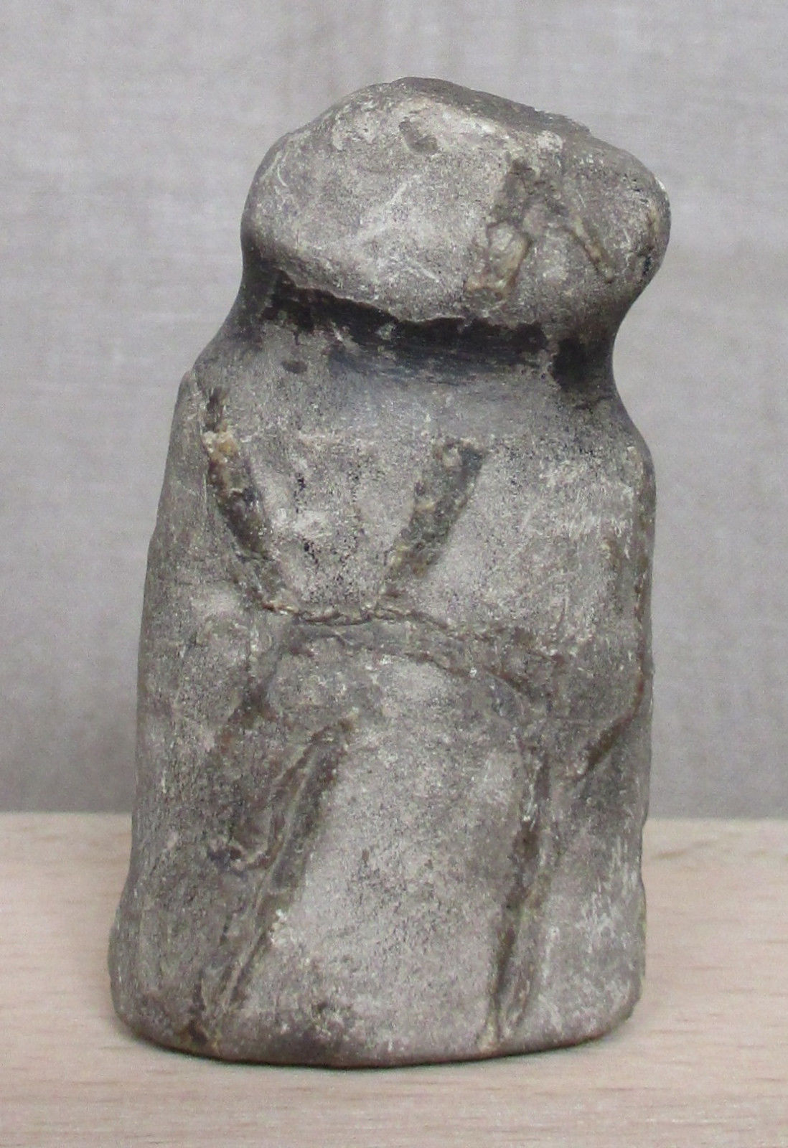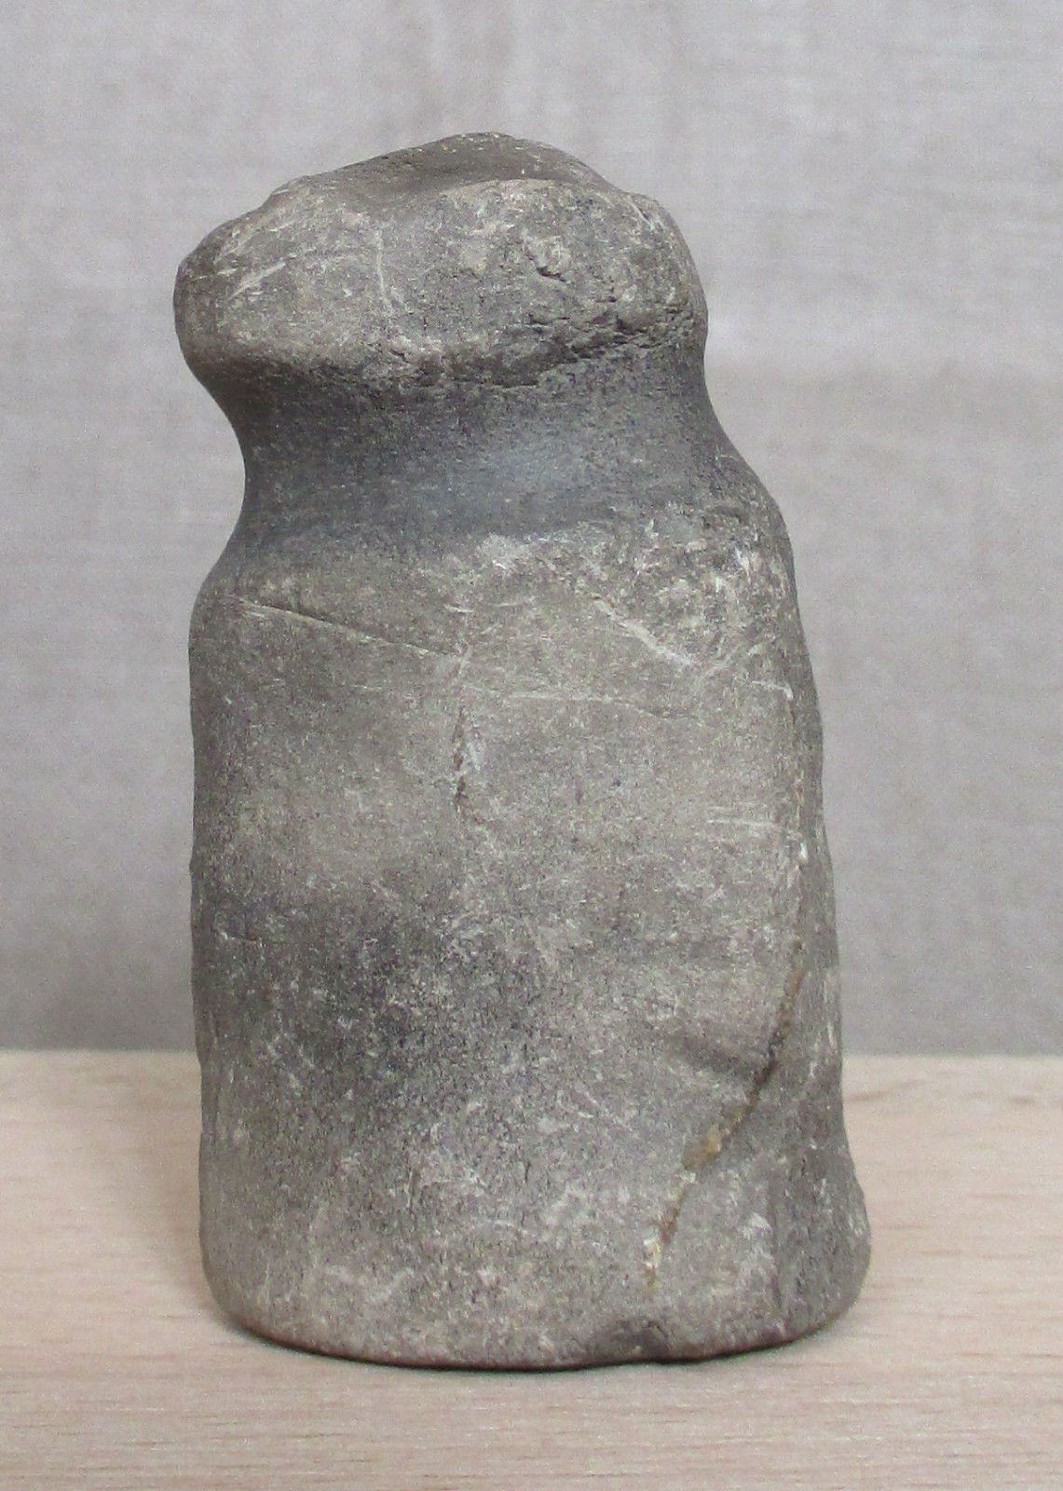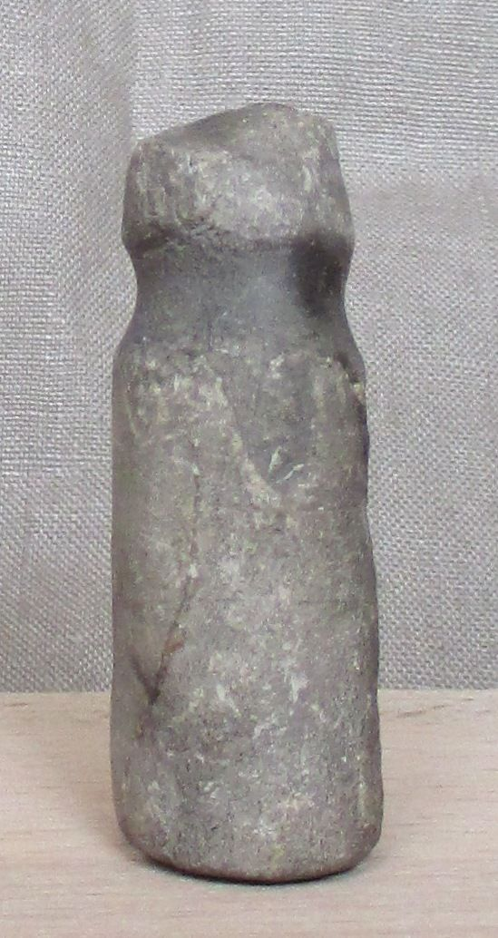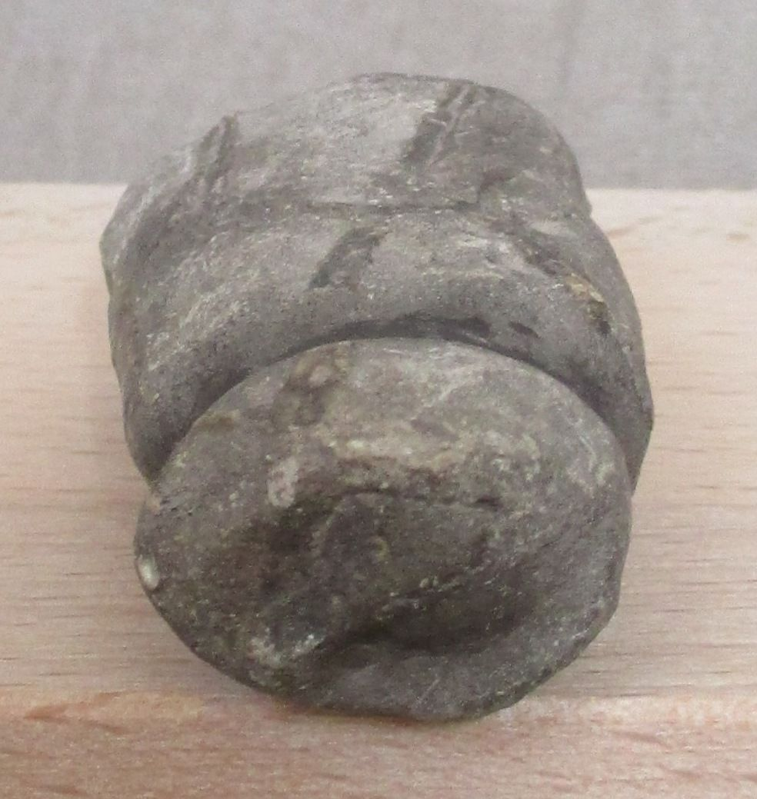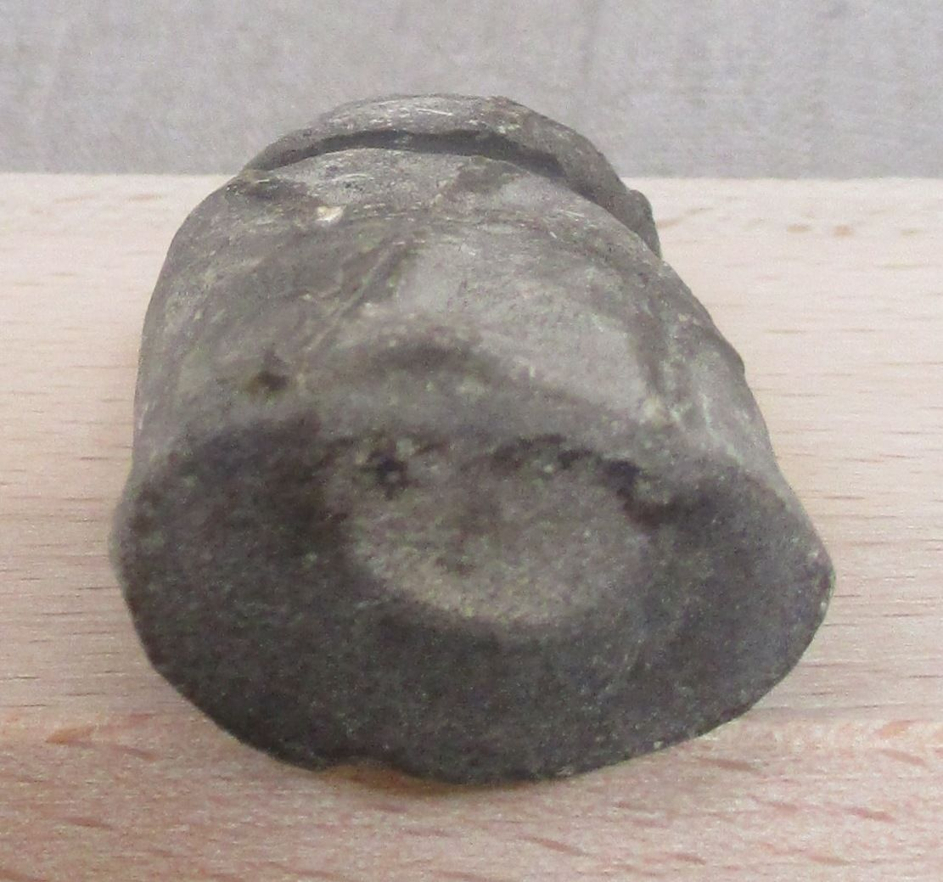

Fig. 1, a-d. Paleolithic Venus figurine from Predmosti**́**, Moravia, Czech Republic, dating to the Würm glaciation, ca. 36,000 BP.

Formal Label: Paleolithic Venus figurine from **Cantabria, Spain**, dating to the **Würm glaciation**, ca. 35,000 BP

Accession Number: A124

**LC Classification:** **DB550.A1**

Date or Time Horizon: **36,000 BP**

Geographical Area: **Cantabria, Spain**

Cultural Affiliation: **Pavlovian period**

Medium: **Limestone**

Dimensions: **H 5.2 cm x 2.8 cm x 1.8 cm (ca. 2.05 x 1.10 x 0.71 in)**

Weight: 43 gm

Provenance: **J. M. R., St Jean Cap, Ferrat, France, from a private archaeologist’s collection from a Spanish inheritance; Atlantika collection 2016.**

**Discussion**: This figurine was carved from limestone and was found in the region of Franco-Cantabria, Spain, near the cave at Altamira. The initial paintings in the Altamira cave were executed ca 35,600 BP and belonged to the Aurignacian culture, at inception of human occupation of the northern Iberian peninsula when Neanderthals were still in the region and also potential painters of the earliest images in the Altamira cave. This suggests that the present figurine may have been carved during the Aurignacian Period ca 36,000 BP and the later paintings in Altamira from the Upper [Solutrean](https://en.wikipedia.org/wiki/Solutrean) (ca 18,500 BP) and the Lower [Magdalenian](https://en.wikipedia.org/wiki/Magdalenian) (ca 16,500-14,000 BP). If this hypothesis is correct then this Cantabria figurine could have been carved earlier than similar shaped figurines from Predmosti**́** near Prerov, Czech Republic, which are dated to 26,800 BP. (see Fig. 3).

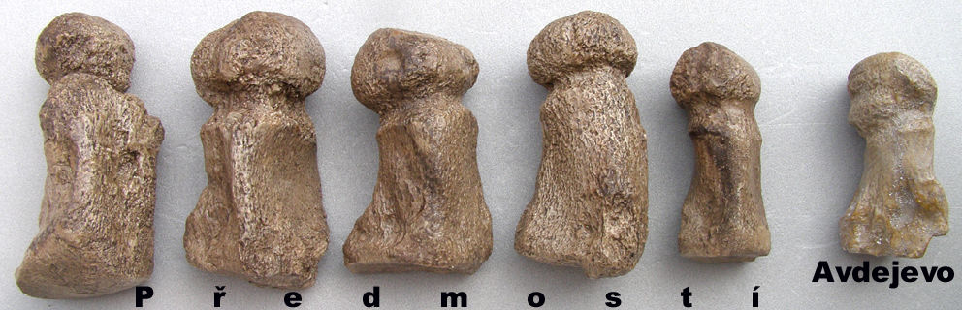

Fig. 3. A series of five female Venus figurines carved from mammoth metatarsals at Predmosti**́** near Prerov, Moravia, dated to 26,800 BP, now in the Moravian Museum in Brno, Czech Republic (Anthropos Institute, accession inv. 11673). The Venus far left is 14.5 cm (5.8 inches) in height. The Venus far right is from Avdejevo and is 10.0 cm (4.0 inches) in height. After <http://i.ebayimg.com/00/s/MzIwWDk5Mg==/z/VbUAAOSwr81USBwg/$_14.JPG>.

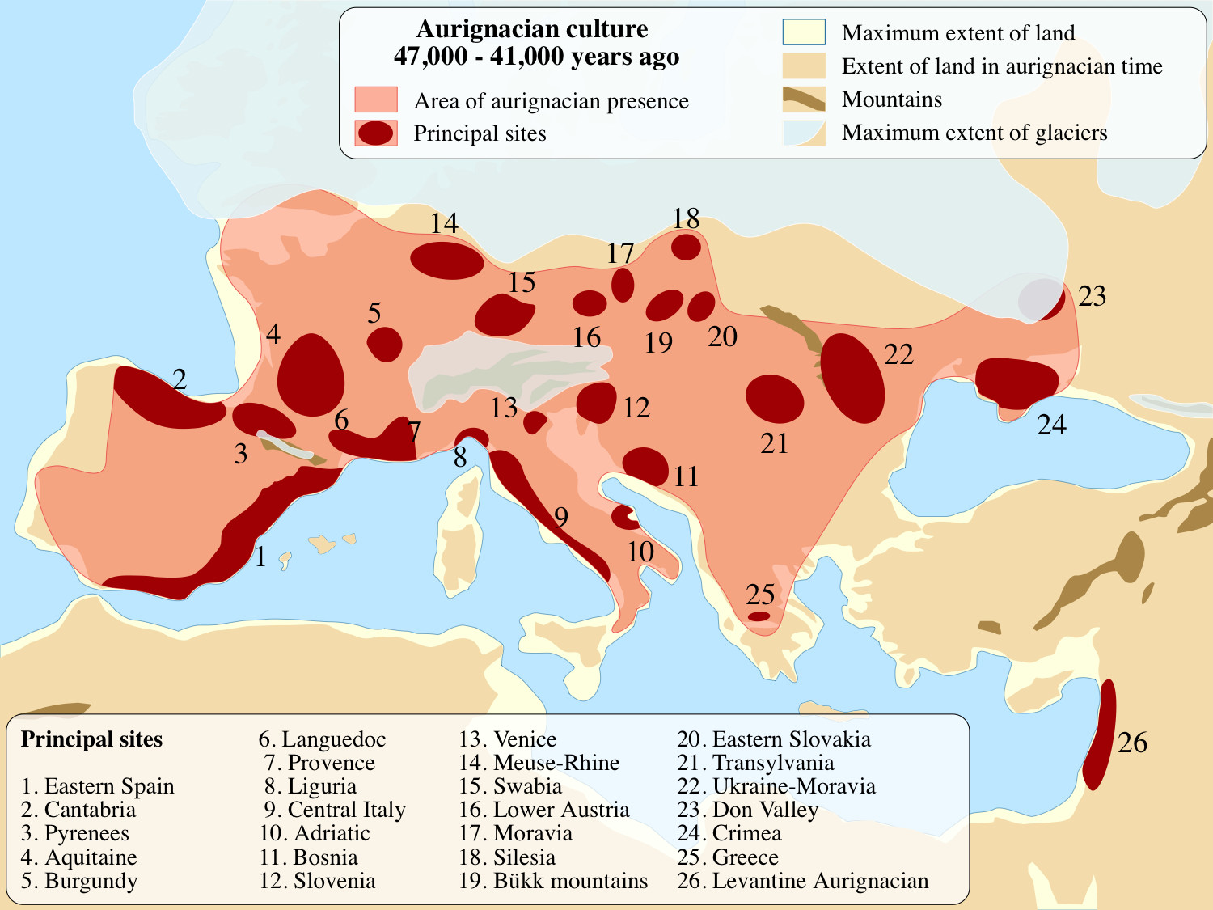

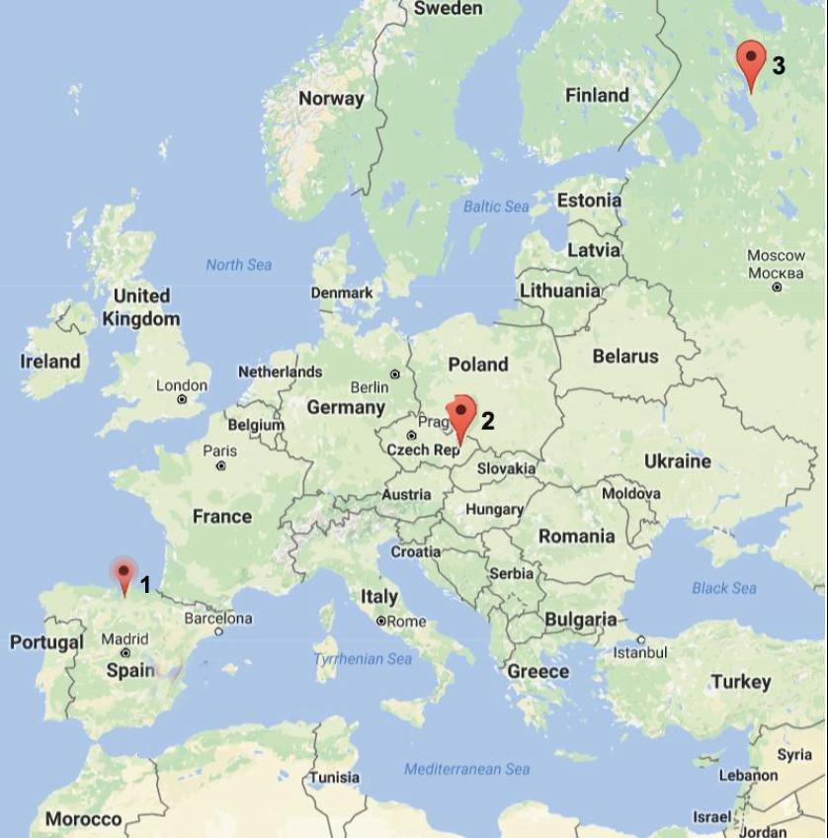

2. Map showing the three locations where the Předmostí type of figurines are found: 1. Iberia (Cantabria); 2. Moravia (Předmostí); 3. Karelia (Avdejevo). These sites suggest a northeast trajectory of of Cromagnon *Homo sapiens sapiens*, who hypothetically entered from the Strait of Gibraltar and spread into Spain and France and central Europe.

**References:**

# Absolon, K., Bohuslav Klíma. 1977. *Predmostí: ein Mammutjägerplatz in Mähren*. **Brno: Archeologický Ústav Ceskoslovenské Akademie Ved v. Brno.**

# de Bruxelles, Simon. June 15, 2012. ["Prehistoric cave art began 10,000 years earlier"](http://www.thetimes.co.uk/tto/science/archaeology/article3445847.ece). The Times*.* Retrieved 18 Feb. 2017.

# Levadoux, L., 1956. *Les populations sauvages et cultivées des Vitis vinifera L* (Vol. 1). Institut national de la récherche agronomique.

Sold by [jmr_06](http://myworld.ebay.com/jmr_06) ( [167](http://feedback.ebay.com/ws/eBayISAPI.dll?ViewFeedback&userid=jmr_06) )

Estimated delivery Wednesday, Dec 7, 2016 - Thursday, Dec 15, 2016

#### [Prehistoric Carved Stone Miniature Anthropomorphic Figure - 2,000 BC or earlier](http://www.ebay.com/itm/122203131101)

|  |  |
| --- | --- |
| Item price | $150.00 |
| Quantity | 1 |
| Item number | 122203131101 |
| Shipping service | Standard Shipping from outside US |